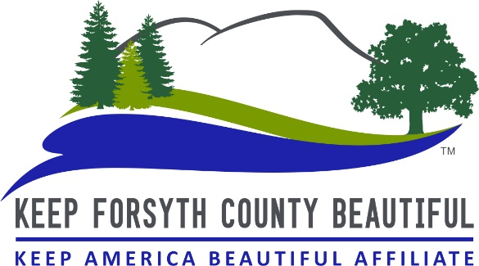
Adopt-A-Road Status Report Form

Date: Click here to enter text

Adopt-A-Road Group/Person’s Name: Click here to enter text

Contact Name: Click here to enter name

Contact’s Phone Number: Click here to enter phone number

County Road Name: Click here to add road name

Number of Bags filled: Enter number here

Number of Participants: Enter number here

Hours Spent On Cleanup: Enter no. of hours here

Does the trash need to be picked up? Enter either “YES” OR “NO” here

If we need to pick up the trash please let us know exactly where it was left:
Fill in trash pickup location here
*** Please turn in this form within 3 days of pickup ***
THANK YOU!
06/2021

