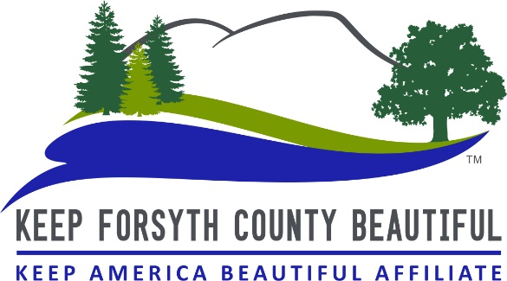

Adopt-A-Road Program Contract

Keep Forsyth County Beautiful and Enter your full name or Group name here recognize the need and desirability of litter free roads.
The Adopt-A-Road program has been established for civic and non-profit organizations, and other interested parties to contribute toward the effort of maintaining litter free roads.
Enter your full name or Group name here is aware of the potentially hazardous work which is to be performed and agrees to abide by the Adopt-A-Road rules and regulations. Also understands that Keep Forsyth County Beautiful agrees to cooperate in the development of the program but cannot assume and liability with respect thereto.
This group and/or individual agrees to conduct a minimum of 1 (one) clean-up per quarter and agrees to submit a status report within 3 (three) business days after each cleanup. Groups that do not clean their adopted road and/or submit reports for 2 (two) consecutive quarters are considered inactive and will be removed from the program.
Name of Organization (if applicable): Enter organization name here
Name of Contact person: Enter contact’s first and last name here
E-mail address: Enter email address here
Contact person best contact number: Enter phone number here
Mailing address: Enter complete street number and street name here
City: Enter city here Zip Code: Enter zip here

The county road we desire to adopt is: (minimum of 1 mile is required) Enter the street name here We will begin each clean up at: Enter the street name (or landmark here) and end at Enter the street name here (or landmark here).

A request for sign installation will be submitted after two (2) quarterly pickups are completed.
I/we would like our sign to read: Enter the name or wording you would like on your sign here

Signature of contact person: Enter contact’s first and last name here
Todays’ date: Enter contact’s first and last name here

Furthermore, I/we accepts the responsibility of picking up litter from both sides of the roadway, completing each quarterly cleanups, submitting a status report to KFCB: 1) by calling 770.205.4573 2) by emailing KFCB@FORSYTHCO.COM or by 3) by mailing a status report to: Keep Forsyth County Beautiful, Attn:AAR, 101 E. Main Street, Cumming GA 30040

